Chapter 6 – Landslides

Rock avalanche – a type of landslide involving sudden failure of large mass of rock that rapidly fragments and travels as a streaming mass at high speeds

Landslides /mass wasting – terms used to describe the downslope movement of rock or sediment due to gravity

Types of landslide determinants:

* The mechanism of movement (fall, topple, slide, flow or complex movement)
* The type of material (rock, consolidated sediment, or organize soil)
* The amount of water present
* The rate of movement

Types of landslides:

* Fall: bounding of rock or blocks of sediment from the face of a cliff
* Slide: downslope movement of a coherent block of rock or sediment along a discrete failure plane
* Slump: particular kind if slide where the failure plane is curved upward
* Flow: is the slow to rapid downslope movement of sediment in which particles move semi-indecently of one another, commonly with the aid of air
* Debris flow: mixtures of mud, debris and water
* Creep: very slow flow of rock or sediment, at EXTREMELY slow rate
  + Sackung: slow movement of large masses of rock
  + topple: slow creep-like movement in which a rock mass pivots about a point

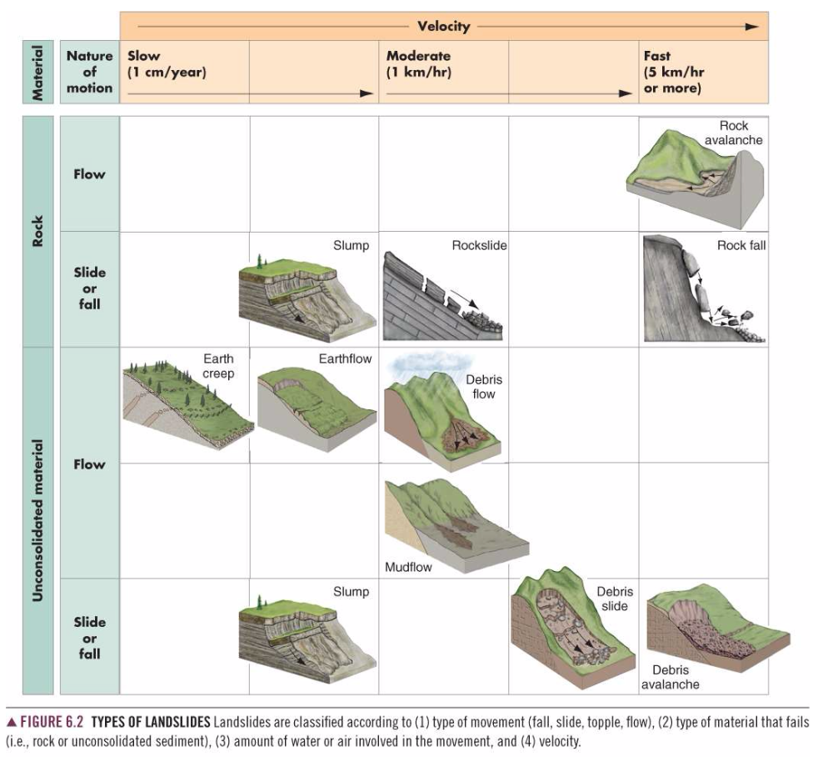

Subaqueous (underwater) landslide – a slump or slide on a submerged slope of a delta or at the edge of a continental shelf can change into a debris flow or a turbidity current that travels at great distanced from the point of failure

Forces on slope – forces that determine the stability of a slope

* Driving forces – move rock or sediment down a slope
  + The weight of slope material is the largest driving force
  + Can include fill material and buildings
* Resisting forces – oppose downslope movement
  + Shear strength of the material
  + Resistance of material to sliding or flowing along slip planes
* Factor of safety(FS) – the ratio of the resisting forces to the driving forces
  + Stable when greater than 1
  + Unstable when less than 1
* Driving and resisting forces are not static – as local condition change, these forces may change, increasing or decreasing FS
* Forces on slopes are determined by:
  + Type of material
    - Mineral composition
    - Degree of sedimentation
    - Planes of weakness
    - Degree of consolidation
    - Shape of slip surface
      * Rotational slides are curved
      * Translational slides are planar
  + Slope angle and topography
    - Slope steepness
      * Steeper the slope, the greater the driving force
      * Steep slopes are associated with falls
      * Moderate slopes are associated with flows
      * Gentle slopes are associated with creep
    - Topographic relief – the height of a hill or mountain above the land below
      * Landslides occur more frequently in areas of high relief
  + Climate – characteristic weather typical of a place or region over years or decades
    - Influences the amount and timing of water that infiltrates or erodes a slope
      * Arid regions are prone to rock falls, debris flows, soil slips; free face and talus slopes are common
      * Humid and sub-humid regions are prone to complex landslides, creep, slides, slumps and debris flows
  + Vegetation
    - Provides a protective cover that reduce the impact of falling rain
    - Plant roots add strength and cohesion to slope materials
    - Adds weight to slopes; increasing the likelihood that the slope will fail
  + Water
    - Saturates soil, causing soil slips and debris flows
    - Slumps develop months or even years following deep infiltration of water into a slope
    - Water erodes base of slopes which decreases stability
    - Can cause spontaneous liquefaction or quick clay failure
      * Fine grained material that loses strength when disturbed and flows like a liquid
  + Time
    - Forces acting on slope change with time
    - Driving and resisting forces change seasonally as the water table fluctuates
    - Chemical weather of rocks occurs slowly over time

Geographic regions at risk of landslides

* Landslides occur wherever there are significant slopes
* In Canada, most common in western cordillera region of BC, Alberta and Yukon and the Appalachian Mountains of Quebec and New Brunswick
* Factors increasing landslide incidence:
  + Urbanization and development of landslide prone areas
  + Tree cutting in landslide prone area
  + Changing global climate patterns resulting in increased precipitation

Linkages with other natural disasters

* Earthquakes, volcanoes, storms and fires may cause landslides
* Landslides may cause flooding or tsunamis

Natural Service Functions of Landslides

* Produce deposits that become mineral resources
  + Weathering frees mineral grains from rocks and landslides transport these materials downslope
  + Ex. Gold and diamonds have been mined from landslide deposits
* Creation of new habitats in forests and aquatic ecosystems
  + Increases plant and animal diversity

Human interaction

* Expansion of urban areas and transportation networks and exploitation of natural resources have increased landslide incidence
* Grading of land surfaces for housing developments can initiate landslides on previously stable slopes
* Timber harvesting
  + Clear cutting (harvesting all trees from large tracts of land) and logging road construction (to remove timber from the forest)
    - Increases landslide related erosion on unstable slopes
    - Interrupts surface drainage, alters subsurface movement and can change the distribution of materials on a slope
* Urbanization
  + Removal of anchoring vegetation
  + Construction of roads and buildings
  + Installing septic systems, watering lawns and gardens
  + Cutting the base of slopes
  + Placing fill materials on slopes

Identification of Potential Landslides

* Crescent shaped cracks or terraces on hillside
* Scalloped/recessed crest of a valley wall
* Tongue shaped area of bare soil or rock on hillside
* Large boulders or pile of talus at the base of a cliff
* An area of tilted trees (jack strawed)
* Trees that are convex at their base but straight higher up

Prevention of landslides

* Drainage control – objective is to keep water from infiltrating a slope
  + Drains can intercept and divert water
* Grading – moving material from the upper slope to the base
  + Improve slope stability
* Slope supports – retaining walls constructed of concrete or brick